**Team Lumen—Achievement Highlights**

**2nd Place – SAP Hackfest (Regional Round)**  
*Techno International New Town, 22 April 2025*  
Team Lumen earned the runner-up spot in the campus-hosted SAP Hackfest, outperforming 25 multidisciplinary teams. The group showcased **Handy – an Affordable Myoelectric Prosthetic Hand**, a functional and low-cost alternative for upper-limb amputees. Designed for accessibility and precision, Handy uses EMG sensors and microcontrollers to interpret muscle signals for intuitive control, reflecting the team's commitment to impactful healthcare innovation.

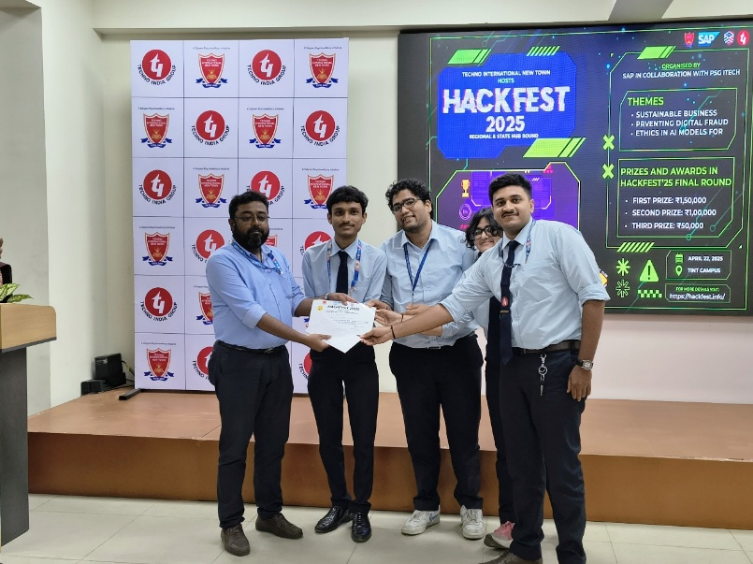

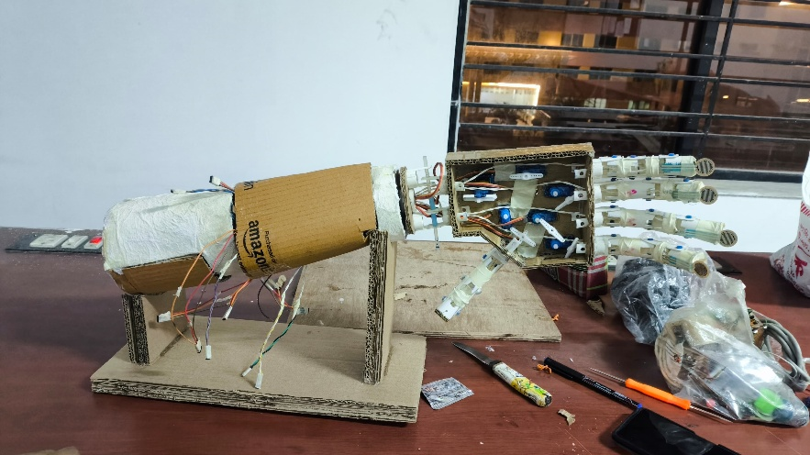

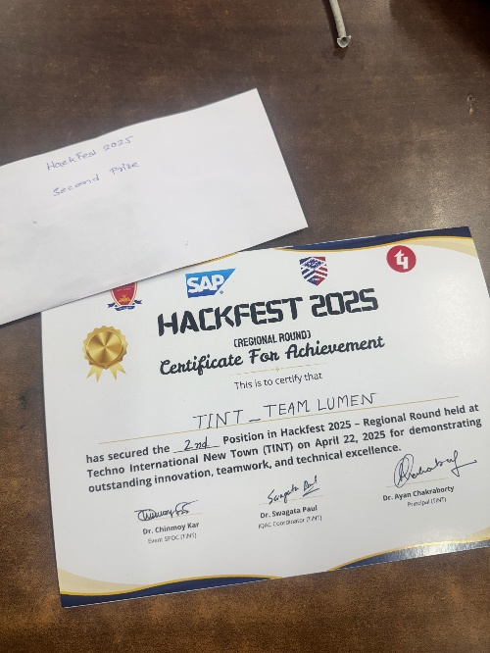

**2nd Place – TELECAST 2024 Model Contest**  
*University of Calcutta – Dept. of Radio Physics, 13 March 2024*  
At the inter-college model exhibition, the original **Smart Streetlight** prototype impressed the judging panel with its cost-effective sensor suite and adaptive dimming algorithm, securing second place among 30 contending projects.

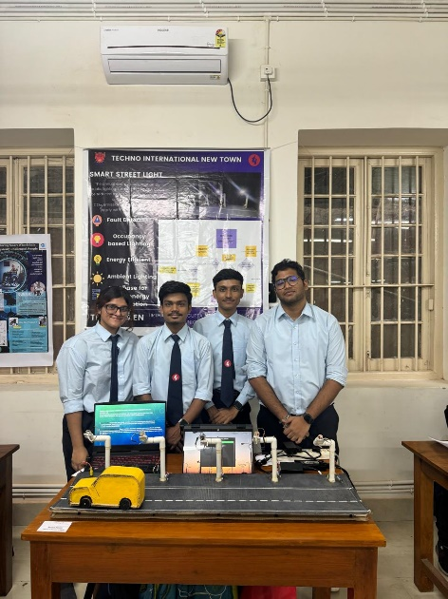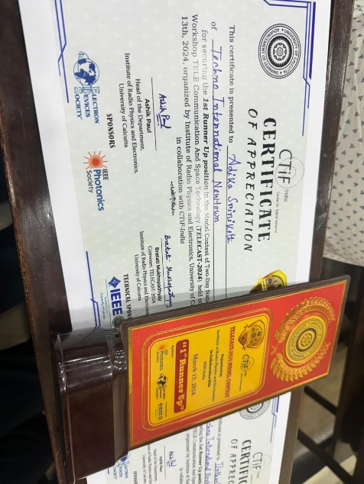

**3rd Place – SparkHack, Convolution 9.0**  
*Jadavpur University – Dept. of Electrical Engineering, 16 March 2024*  
Following a two-stage evaluation that included a virtual pitch and on-site demonstration, Team Lumen clinched third place by showcasing the practical scalability of its Smart Streetlight solution for smart-city deployments.

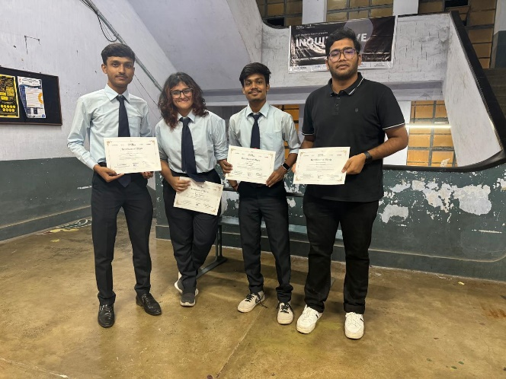 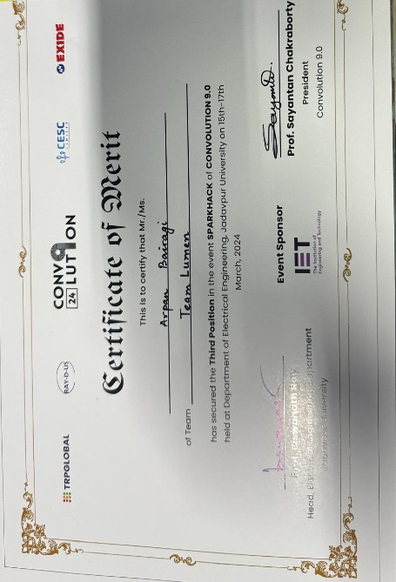

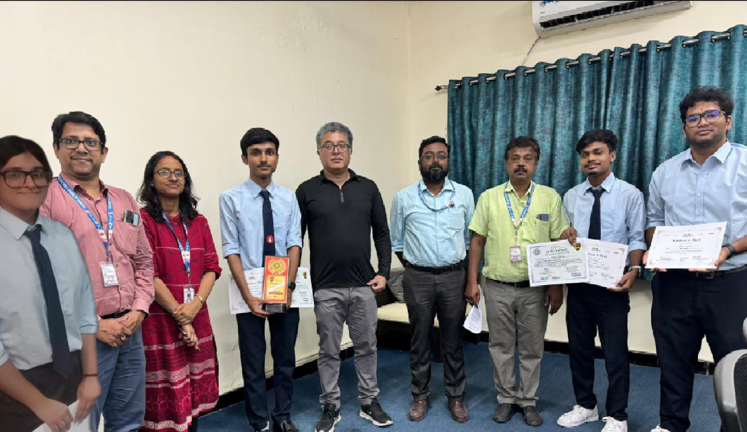

*About Team Lumen*  
Formed by ECE undergraduates, Team Lumen is dedicated to designing affordable, sustainable smart-city and healthcare technologies. Their flagship Smart Streetlight system leverages IoT sensors, PID-controlled drivers, and cloud analytics to cut municipal lighting energy consumption while enhancing public safety. The team is also expanding into biomedical innovations, such as the Handy prosthetic hand, to improve lives through engineering.